Alloy cam pulleys

We have arranged for a small batch of alloy cam pulleys to be manufactured for the Vauxhall SOHC slant four engines. There are 2 versions, a direct replacement for standard pulley which can be used for the cam or auxiliary shaft and an adjustable unit using 6 clamp bolt vernier adjustment allowing perfect setting for any modified engine. These pulleys are made from 6082 aluminium for good mechanical strength and are hard anodised to improve the wear rate on drive teeth.
Please note; These parts may still wear if they are used in poor road conditions or if the cam belt is set too tight.
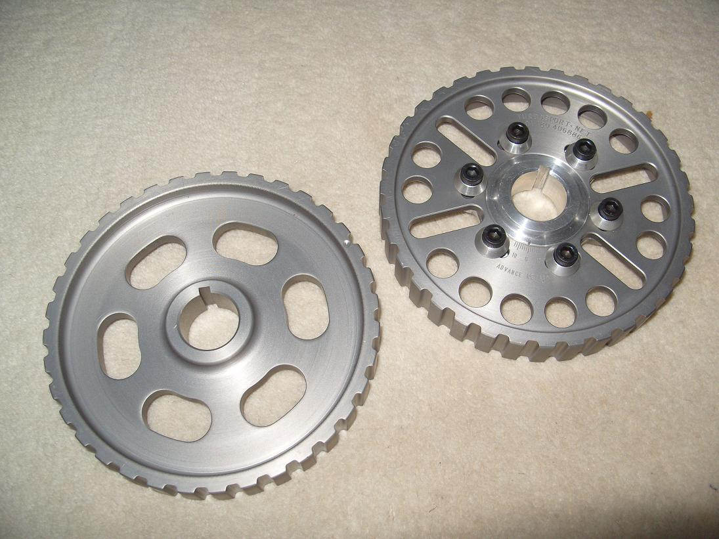
Standard - £80.00
Adjustable - £125.00
If you are interested please contact us

